**Steps to install / uninstall the entity relationship diagram generation tool in D365FO**

Installation Steps:

1. Download “ERDDataModel.zip” deployable package
2. Import the deployable package in asset library

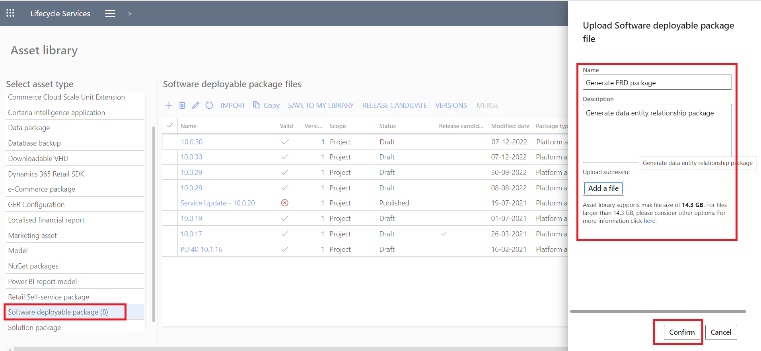

1. Apply the package to the D365 F&O environment

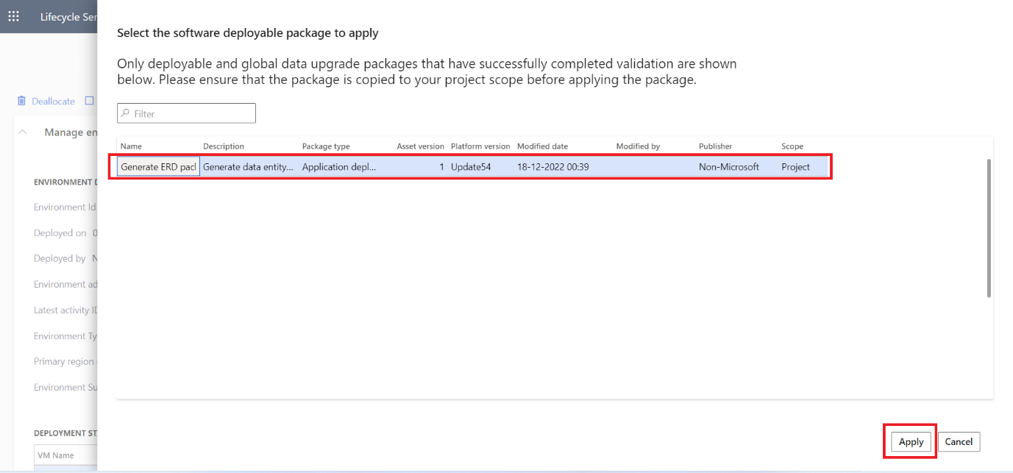

1. Wait for the package to be deployed successfully in order to use the tool

Uninstallation Steps:

1. Download “Uninstall_ERDDataModel.zip” deployable package
2. Import the deployable package in asset library
3. Apply the package to the D365 F&O environment
4. Wait for the package to be deployed successfully to uninstall the tool